Create new Folder

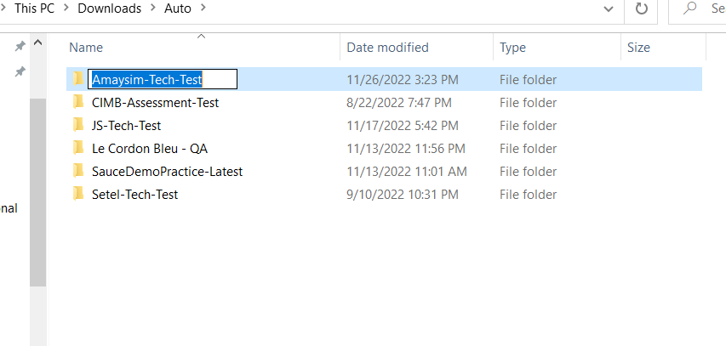

Open Folder from IDE (Visual Studio)

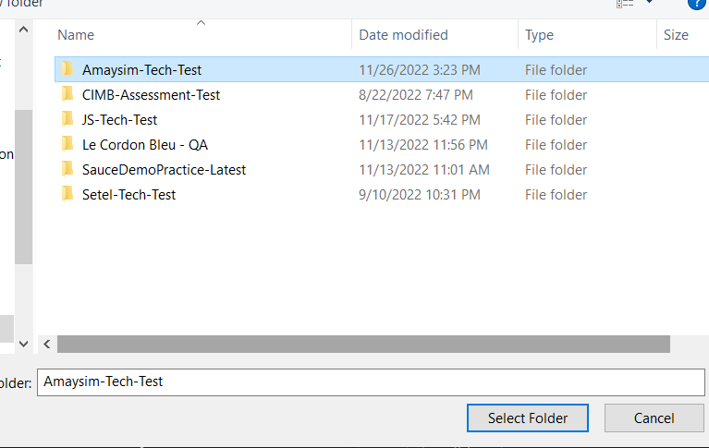

Open Terminal

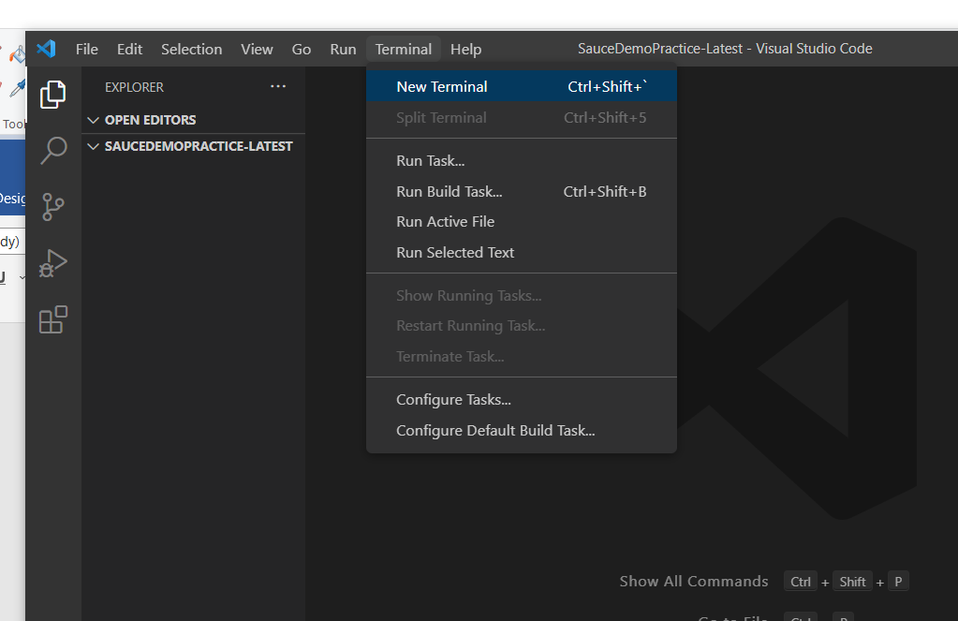

npm init -y (yes to all for faster setup, package.json will be created)

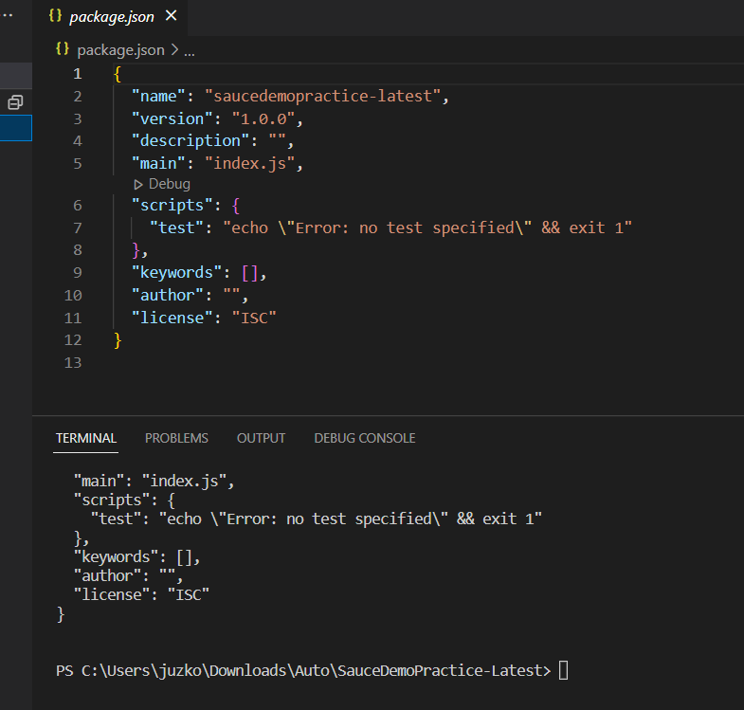

For Dev Dependencies

npm install cypress --save-dev (installing cypress with dev dependencies and getting the node_modules, package-lock.json, or just use **npm i -D cypress**)

npm i -D @badeball/cypress-cucumber-preprocessor @esbuild-plugins/node-modules-polyfill (cucumber dependencies for the latest cypress version)

npm i -D @bahmutov/cypress-esbuild-preprocessor (to connect cypress with esbuild)

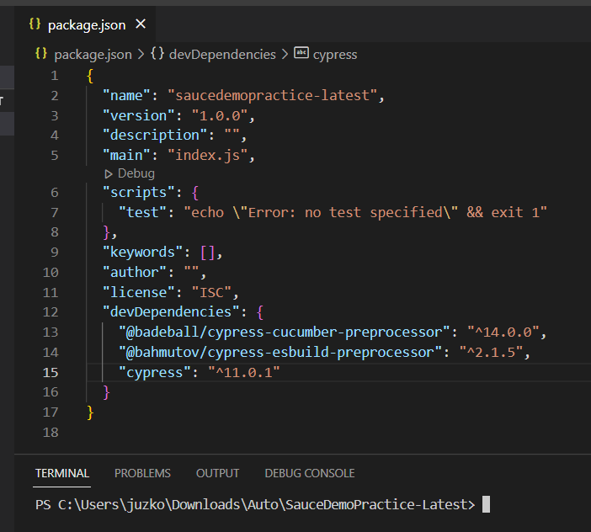

npx cypress open (to generate cypress.config.js)

-select e2e testing

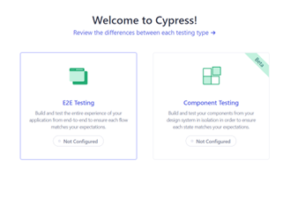

-click continue

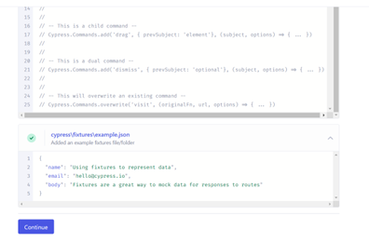

-select browser

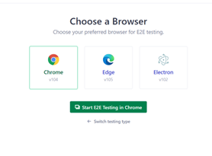

-you can skip the spec part

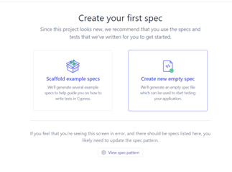

npx cypress open --e2e --browser chrome (or just use this for shortcut)

-then just click continue

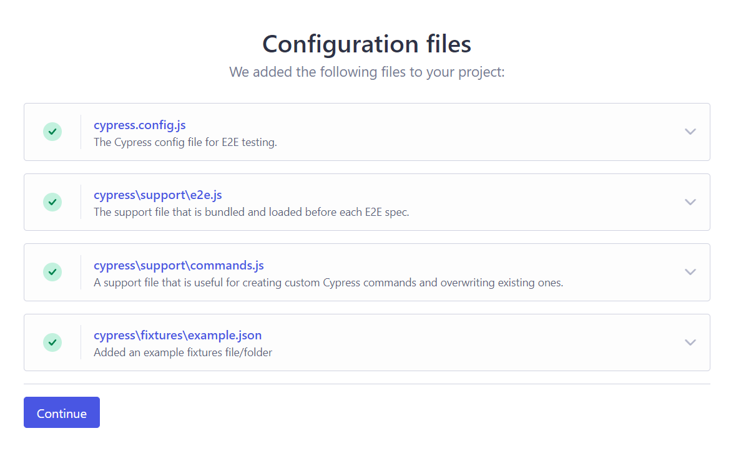

-Modify cypress.config.js

-from this

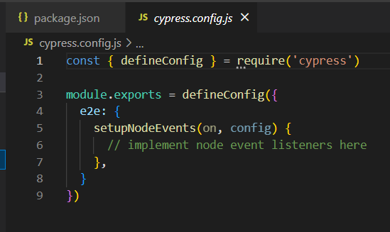

-to this

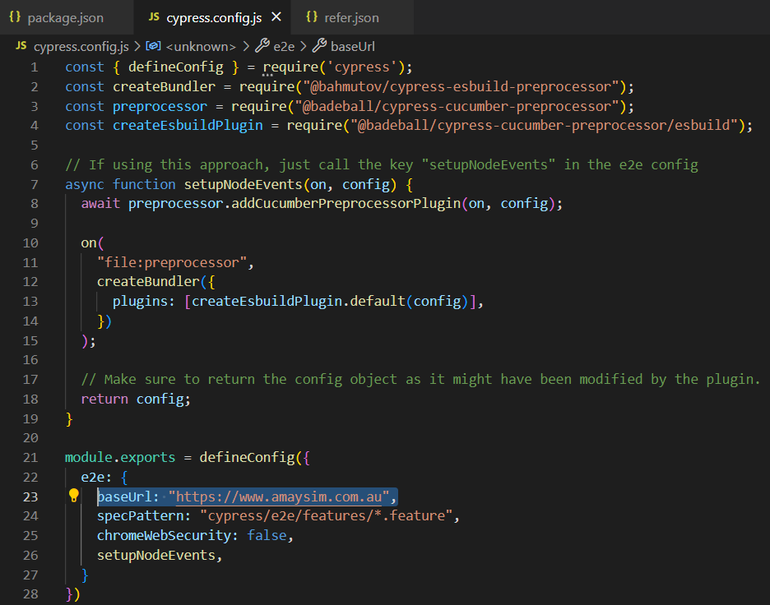

-Create a feature file (cypress/e2e/features/*.feature)

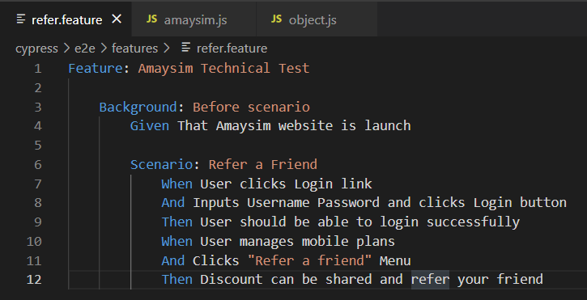

-Create a step definition file (cypress/support/step_definitions/*.cy.js)

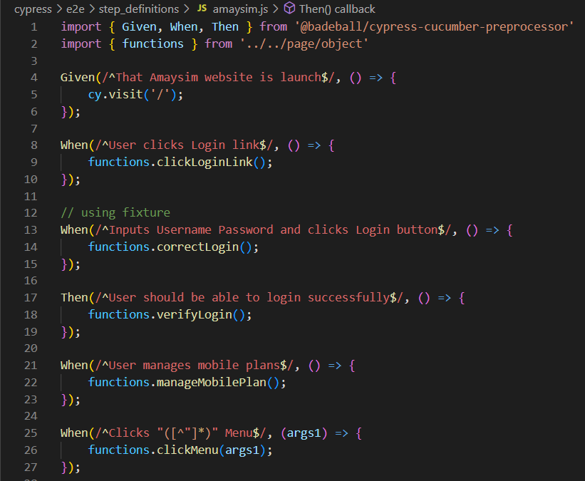

-Create a json file for configurations (.cypress-cucumber-preprocessorrc.json)

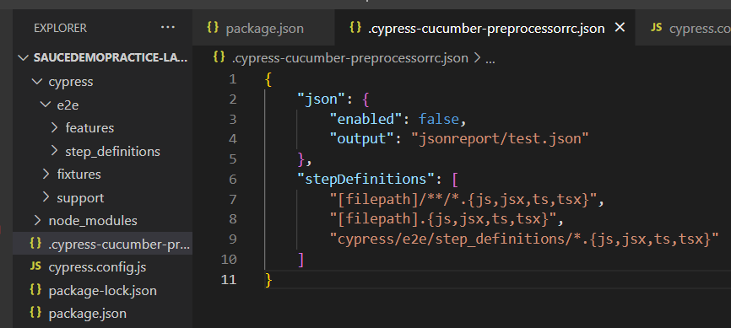

-Start adding objects needed for your script

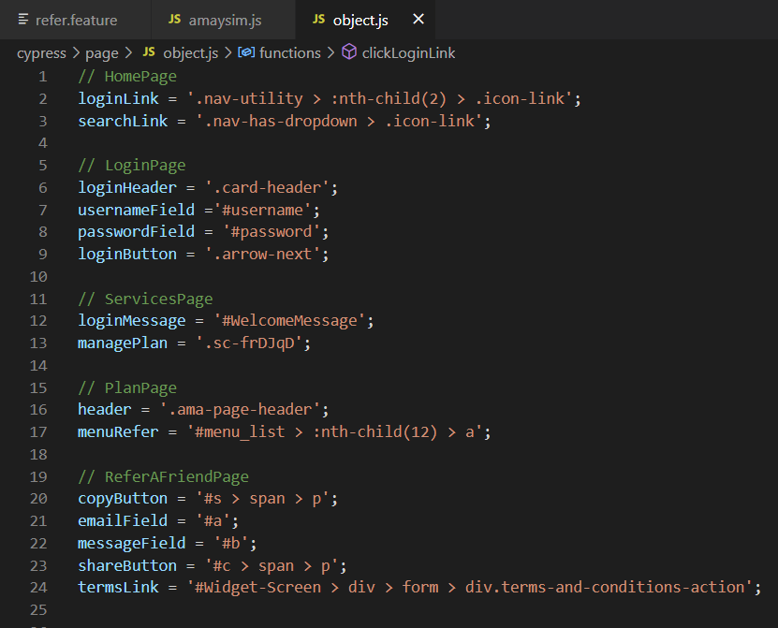

You can customize this part for execution (under package.json)

-This 2 are for opening and executing scripts using the dashboard

    "shortDB": "npx cypress open --e2e --browser chrome",

    "longDB": "npx cypress open",

-While this for running in terminal or cmd

"cmd": "cypress run -b chrome -s 'cypress/e2e/features/refer.feature'"